# API Gateway - Request Validator

## How to fix Internal server errors?

Language Input query string parameter is not supplied

<https://b7lssaroyi.execute-api.us-east-1.amazonaws.com/stage5/serverless/Rohit>

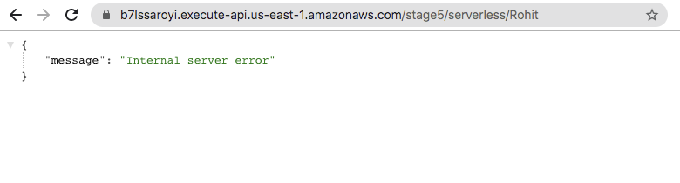

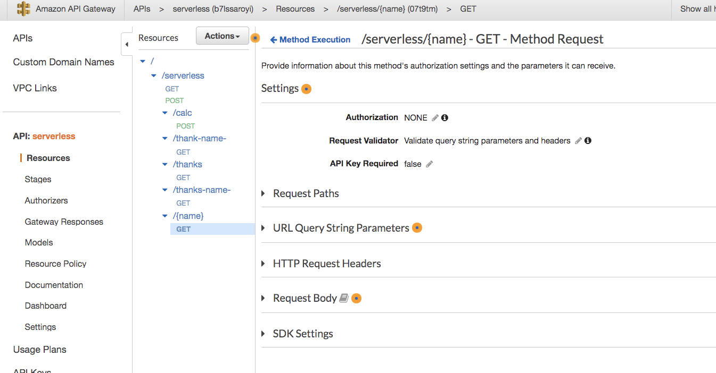

## URL Query String Parameters

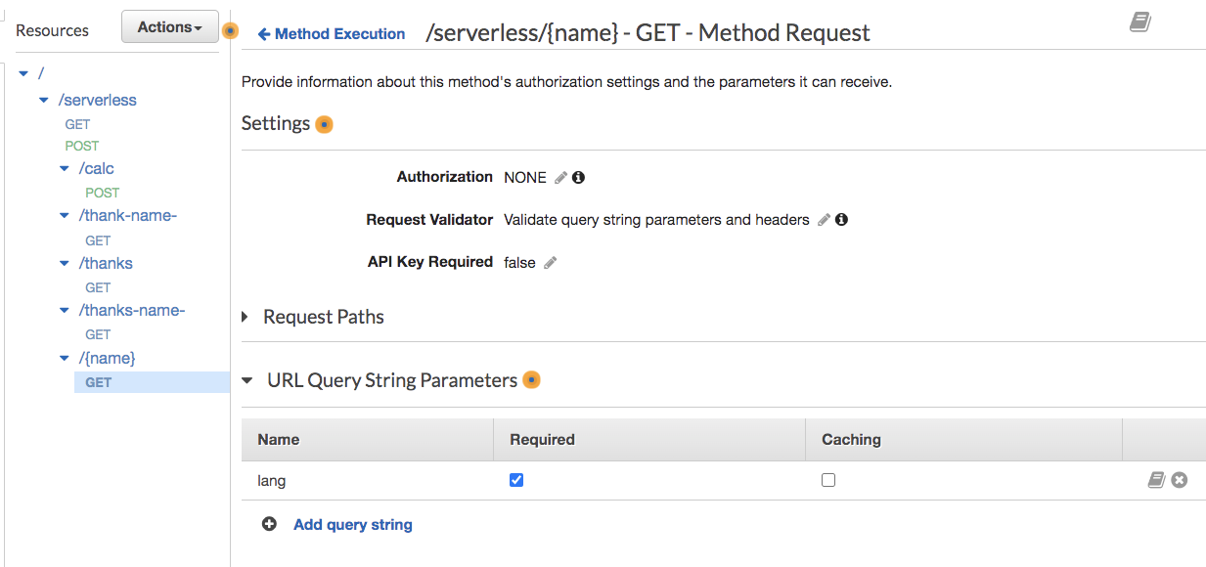

## Test the Validation

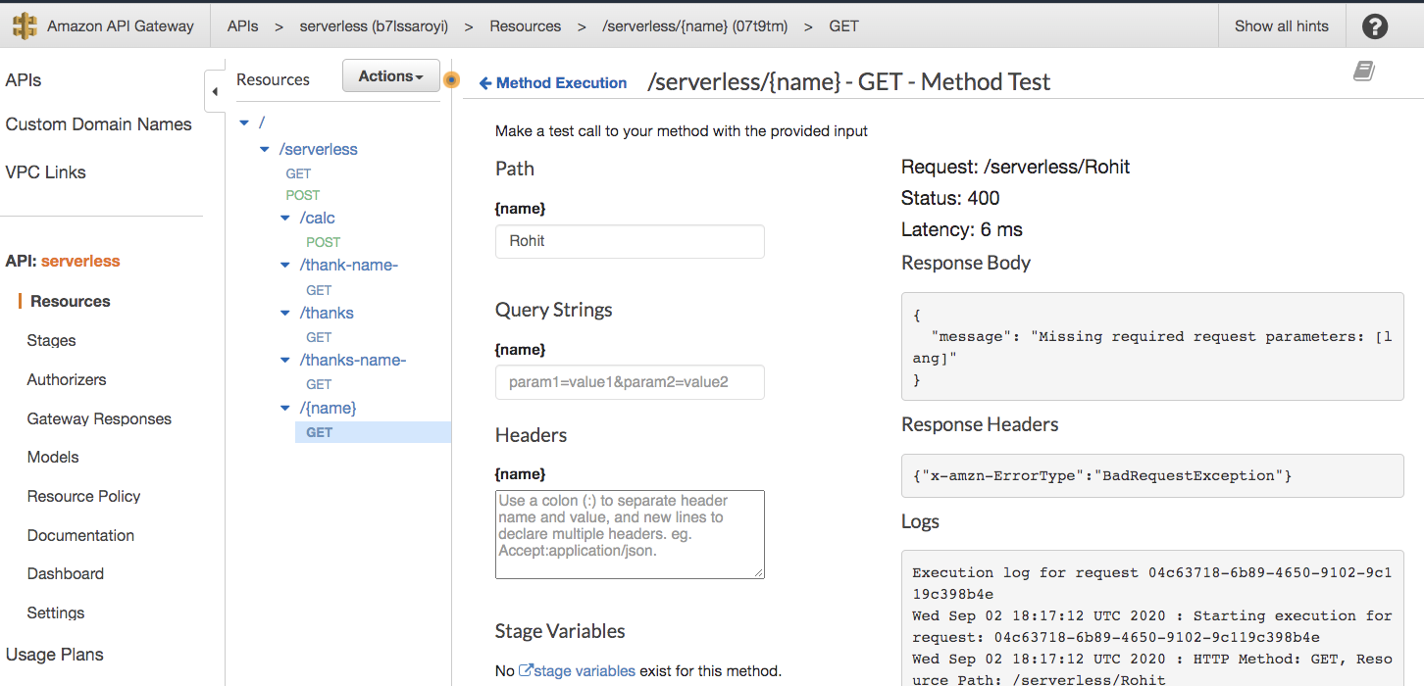

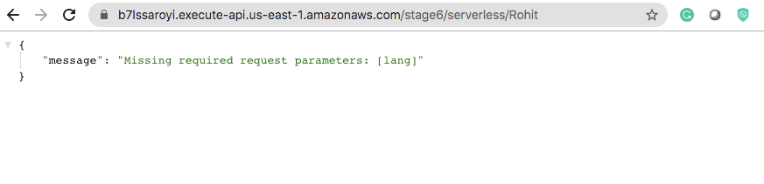

<https://b7lssaroyi.execute-api.us-east-1.amazonaws.com/stage6/serverless/%7Bname%7D>

